SDA Assignment 1

21K-3153

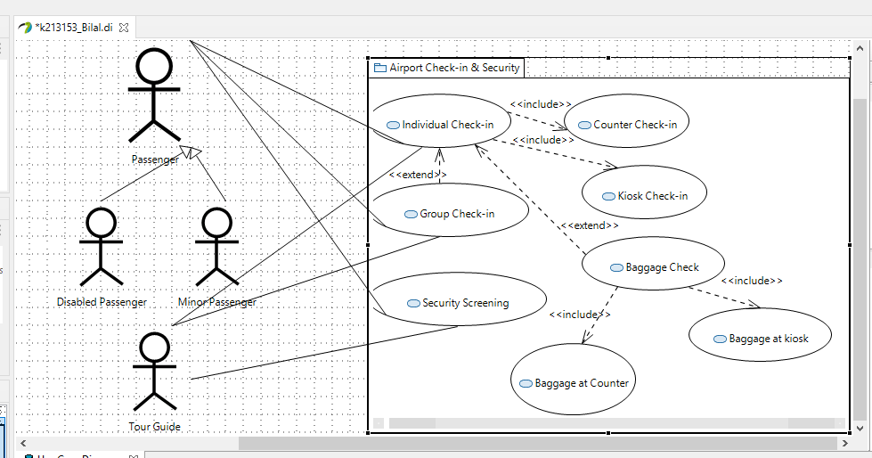

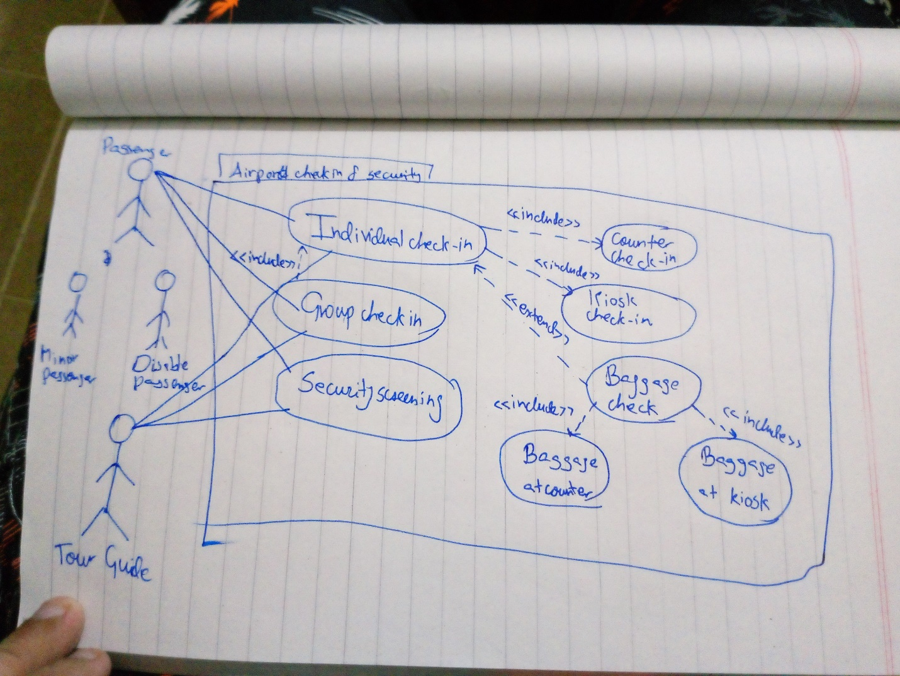

Description:

The use case diagram illustrates how passengers (minors and disabled included) and tour guides interact with an Airport Check in and Security System. Services included are individual or group check in at a counter or kiosk, security screening and optional baggage handling at a kiosk or counter if a passenger is carrying luggage. Description of each use case is below.

Individual Check-in: Done by solo passengers or a solo tour guide either at a counter or at a kiosk.

Group Check-in: Done by groups of passengers, however the check in process is always done individually, hence Individual Check-in is the only option included in Group Check-in.

Security Screening: accessible by Tour Guides and passengers.

Counter Check-in: One of the two options available for passengers checking in individually.

Kiosk Check-in: One of the two options available for passengers checking in individually.

Baggage Handling: If a passenger is carrying luggage, airport carries baggage for them.

Baggage at counter/kiosk: if passenger checks in at counter or kiosk and is carrying luggage, airport handles it for them.